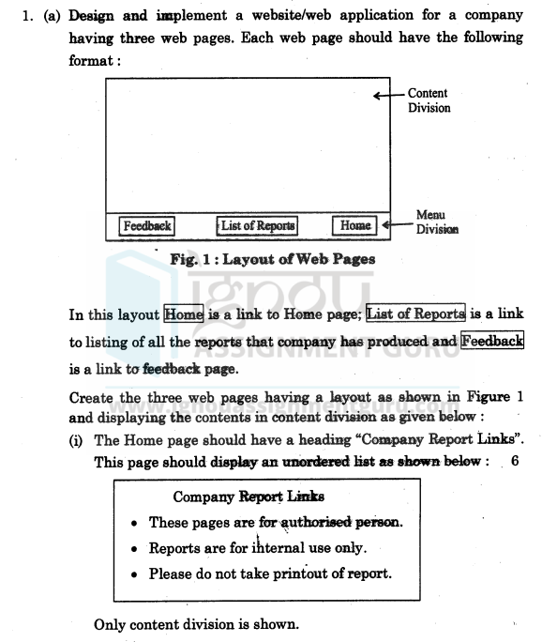

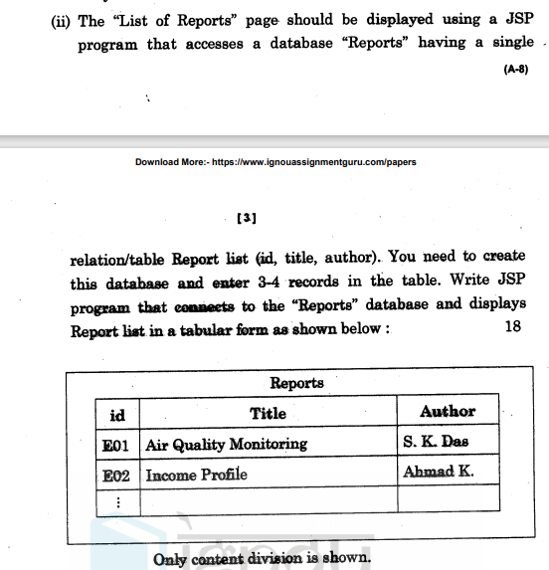

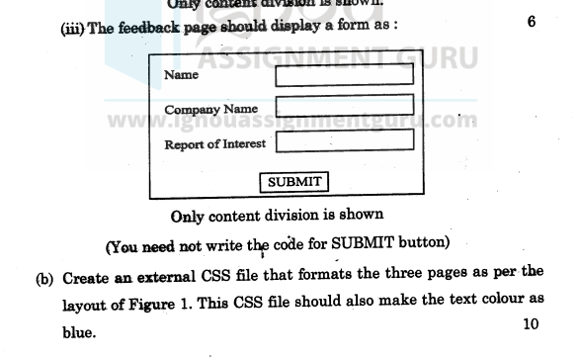

**Home.html**

<!DOCTYPE html>

<html lang="en">

<head>

<meta charset="UTF-8">

<meta name="viewport" content="width=device-width, initial-scale=1.0">

<link rel="stylesheet" href="styles.css">

<title>Company Report Links</title>

</head>

<body>

<div class="content">

<h1>Company Report Links</h1>

<ol>

<li>Company reports link</li>

<li>These pages are for authorised persons</li>

<li>Reports are for internal users only</li>

<li>Please do not take print out of reports</li>

</ol>

</div>

<div class="menu">

<ul>

<li><a href="home.html">Home</a></li>

<li><a href="listReports.jsp">List of Reports</a></li>

<li><a href="feedback.html">Feedback</a></li>

</ul>

</div>

</body>

</html>

**ListReports.jsp**

<%@ page import="java.sql.*" %>

<%@ page contentType="text/html; charset=UTF-8" %>

<!DOCTYPE html>

<html lang="en">

<head>

<meta charset="UTF-8">

<meta name="viewport" content="width=device-width, initial-scale=1.0">

<link rel="stylesheet" href="styles.css">

<title>List of Reports</title>

</head>

<body>

<div class="content">

<h1>List of Reports</h1>

<table border="1">

<tr>

<th>Report Title</th>

<th>Author</th>

</tr>

<%

// Database connection code

String dbURL = "jdbc:mysql://localhost:3306/Reports"; // Replace with your database connection string

String dbUsername = "root"; // Replace with your database username

String dbPassword = ""; // Replace with your database password

Connection conn = null;

Statement stmt = null;

ResultSet rs = null;

try {

Class.forName("com.mysql.cj.jdbc.Driver"); // MySQL JDBC driver

conn = DriverManager.getConnection(dbURL, dbUsername, dbPassword);

stmt = conn.createStatement();

String query = "SELECT * FROM report_list";

rs = stmt.executeQuery(query);

while (rs.next()) {

String title = rs.getString("title");

String author = rs.getString("author");

%>

<tr>

<td><%= title %></td>

<td><%= author %></td>

</tr>

<%

}

} catch (Exception e) {

e.printStackTrace();

} finally {

try {

if (rs != null) rs.close();

if (stmt != null) stmt.close();

if (conn != null) conn.close();

} catch (SQLException se) {

se.printStackTrace();

}

}

%>

</table>

</div>

<div class="menu">

<ul>

<li><a href="home.html">Home</a></li>

<li><a href="listReports.jsp">List of Reports</a></li>

<li><a href="feedback.html">Feedback</a></li>

</ul>

</div>

</body>

</html>

**Feedback.html**

<!DOCTYPE html>

<html lang="en">

<head>

<meta charset="UTF-8">

<meta name="viewport" content="width=device-width, initial-scale=1.0">

<link rel="stylesheet" href="styles.css">

<title>Feedback</title>

</head>

<body>

<div class="content">

<h1>Feedback Form</h1>

<form action="#">

<label for="name">Name:</label><br>

<input type="text" id="name" name="name" required><br><br>

<label for="companyName">Company Name:</label><br>

<input type="text" id="companyName" name="companyName" required><br><br>

<label for="reportInterest">Report of Interest:</label><br>

<input type="text" id="reportInterest" name="reportInterest" required><br><br>

<input type="submit" value="Submit">

</form>

</div>

<div class="menu">

<ul>

<li><a href="home.html">Home</a></li>

<li><a href="listReports.jsp">List of Reports</a></li>

<li><a href="feedback.html">Feedback</a></li>

</ul>

</div>

</body>

</html>

**DB Structure**

CREATE DATABASE Reports;

USE Reports;

CREATE TABLE report_list (

id INT AUTO_INCREMENT PRIMARY KEY,

title VARCHAR(255) NOT NULL,

author VARCHAR(255) NOT NULL

);

INSERT INTO report_list (title, author) VALUES

('Annual Financial Report', 'John Doe'),

('Marketing Analysis', 'Jane Smith'),

('Q4 Project Update', 'Alex Brown');

**External CSS**

/* Base styles */

body {

font-family: Arial, sans-serif;

color: blue;

margin: 0;

padding: 0;

}

.content {

padding: 20px;

background-color: #f4f4f4;

min-height: 80vh;

}

.menu {

position: fixed;

bottom: 0;

width: 100%;

background-color: #333;

color: white;

text-align: center;

padding: 10px 0;

}

.menu ul {

list-style: none;

padding: 0;

}

.menu ul li {

display: inline;

margin-right: 20px;

}

.menu ul li a {

color: white;

text-decoration: none;

font-weight: bold;

}

.menu ul li a:hover {

text-decoration: underline;

}

/* Feedback form */

form {

display: flex;

flex-direction: column;

}

form input[type="text"] {

padding: 8px;

margin: 5px 0;

width: 250px;

}

form input[type="submit"] {

background-color: blue;

color: white;

border: none;

padding: 10px;

cursor: pointer;

}

form input[type="submit"]:hover {

background-color: darkblue;

}

/* Table styling */

table {

width: 100%;

border-collapse: collapse;

margin-top: 20px;

}

table, th, td {

border: 1px solid blue;

}

th, td {

padding: 10px;

text-align: left;

}

th {

background-color: #f0f0f0;

}